|  |
| --- |
| H9122L ( 47~862MHz)  FTTH Digital TV Low Optical Receiver |

|  |  |  |
| --- | --- | --- |
| **Product description** |  | |
| Guangtai H9122L, operating bandwidth of 47 ~ 862MHz, is a suitable digital television FTTH applications, ultra-low optical receiver, Whether used in analog television or digital television. Receiving at high optical power can be adjusted by PAD level, played limiting output, so H9122L within a large dynamic range of the received optical power of +2 dBm ~-20dBm, have excellent characteristics.  H9122L for Analog TV, in Pin =-10dBm when, Vo ≥ 86dBμV, CNR ≥ 45dB.  H9122L for Digital TV, in Pin =-15dBm when, Vo ≥ 84.1dBμV, MER ≥ 36.7dB. | C:\Users\ADMIN\Desktop\新建文件夹\H9122L.jpgH9122L | |
| H9122L for Digital TV, in Pin =-20dBm when, Vo ≥ 74.8dBμV, MER ≥ 29.6dB.  Digital TV FTTH applications, the H9122L can save a lot of optical fiber amplifier power resources. For operators, can greatly reduce the cost of building the network. Suitable for rural power digital TV, FTTH, triple play of wide application.  H9122L optical port mode of the following three selection:  H9122L : operating wavelength 1260~1620nm.A-Type  H9122L/WD: built-in CWDM, suitable for single-fiber triple wavelength system, CATV operating wavelength 1550nm, pass wavelength 1310/1490nm, can conveniently connect the ONU of EPON, GPON. B-Type.  H9122L/WF: built-in 1310/1490nm filter, suitable for single-fiber triple wavelength system CATV operating wavelength 1550nm. A-Type | | |
| **Product features**  ▶Extra-low noise(3.8% modulate, -10dBm receive, CNR ≥ 45dB)  ▶Wide dynamic receiving optical power range: within Pin=-15, MER≥36.7dB  ▶Applicable GPON, EPON, compatible with any FTTx PON technology  ▶Can save a large number of optical power resource, greatly reduce the network configuration cost  ▶In the range of 47~862MHz, all have good flatness (FL ≤± 0.75dB)  ▶Metal shell, supply safeguards to optoelectronic sensing device  ▶Low consumption, high performance, high reliability  ▶Low power consumption, high cost performance | | **Main application**  ▶Digital TV FTTH  ▶Integration of three networks  ▶FTTH PON  **Status Indication**  ▶Red : >+2dBm  ▶Green : +2~-16dBm  ▶Orange : -16~-20dBm  ▶Red : <-20dBm  Note: Users can set the order request |

**H9122L/WD The application in Single-fiber Three-wavelength**

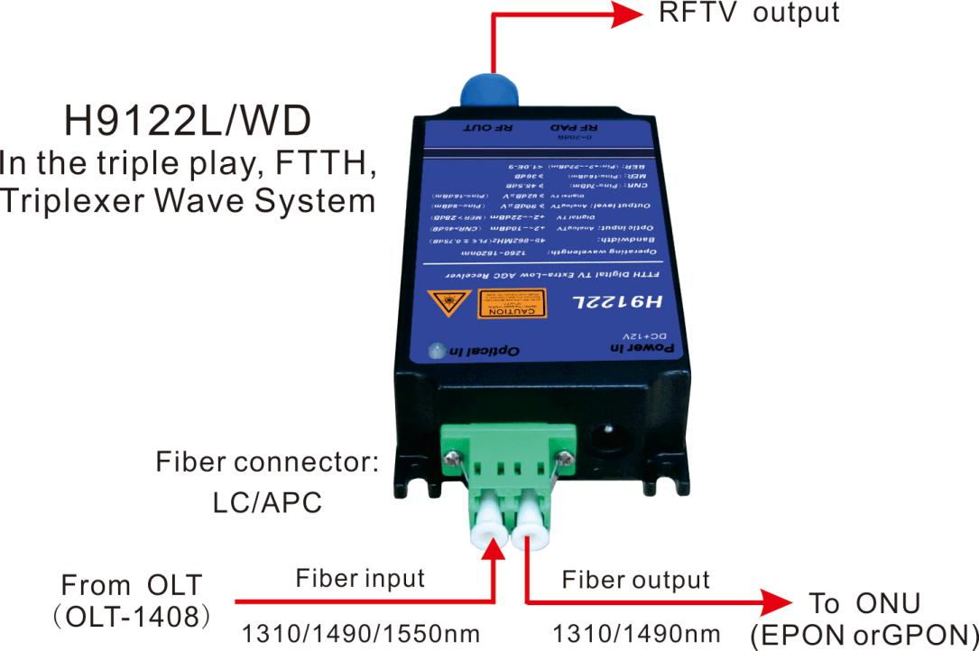

**Dimensions**

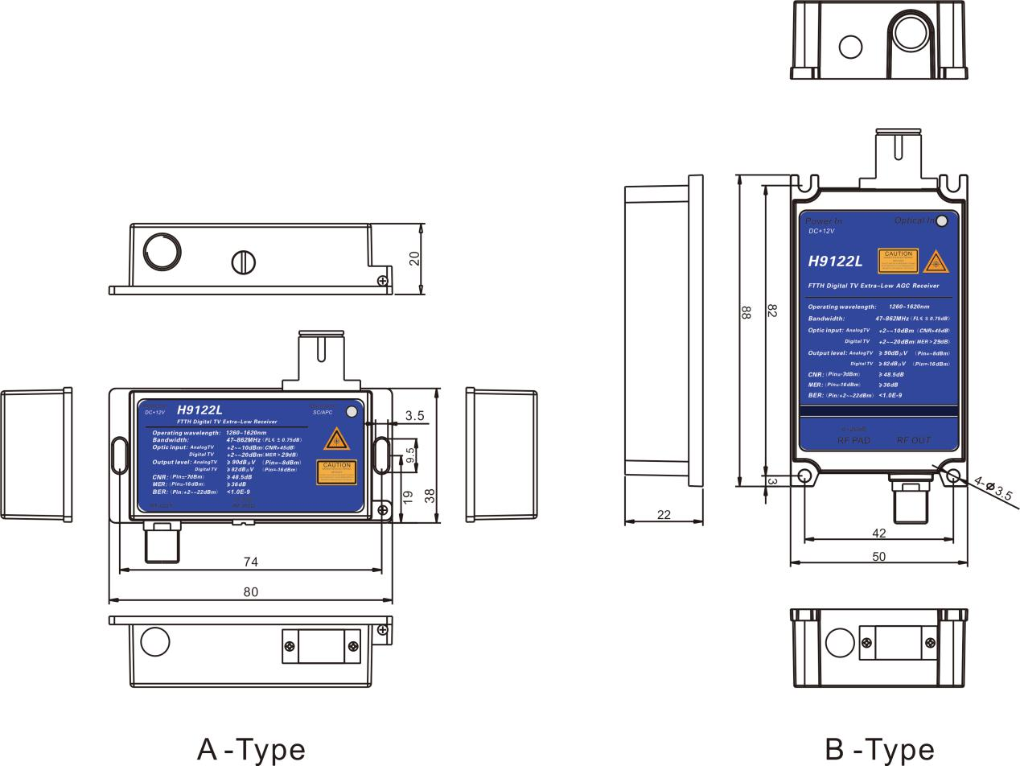

**Technical index**

|  |  |  |  |  |
| --- | --- | --- | --- | --- |
| Performance | | | Index | Supplement |
| Optic feature | CATV work wavelength | (nm) | 1260~1620 | H9122L(A-Type) |
| 1540~1563 | H9122L/WF, H9122L/WD(A&B Type) |
| Pass wavelength | (nm) | 1310,1490 | H9122L/WD (B Type) |
| Channel Isolation | (dB) | ≥40 | 1550nm & 1490nm |
| Responsivity | (A/W) | ≥0.85 | 1310nm |
| ≥0.9 | 1550nm |
| Receiving power | (dB) | +2~-10 | Analog TV(CNR>45dB) |
| +2~-20 | Digital TV(MER>29dB) |
| Optical return loss | (dB) | ≥55 |  |
| Optical fiber connector |  | SC/APC | H9122L, H9122L/WF |
| LC/APC | H9122L/WD |
| RF feature | Work bandwidth | (MHz) | 47~862 |  |
| Flatness | (dB) | ≤±0.75 | 47 ~ 862MHz |
| Output level | (dBμV) | >90 | Analog TV (Pin=-8dBm) |
| >82 | Digital TV (Pin=-16dBm) |
| Output level adjust | (dB) | 0~18 | MGC |
| Return loss | (dB) | ≥14 | 47 ~ 862MHz |
| Output impedance | (Ω) | 75 |  |
| Output port number |  | 1 |  |
| RF tie-in |  | F-Female |  |
| Analog TV Link feature | Test channel | (CH) | 59CH(PAL-D) |  |
| OMI | (%) | 3.8 |  |
| CNR1 | (dB) | 54.1 | Pin=-2dBm |
| CNR2 | (dB) | 45.2 | Pin=-10dBm |
| CTB | (dB) | ≤-65 | Pin:0~-10dBm |
| CSO | (dB) | ≤-65 | Pin:0~-10dBm |
| Digital TV Link feature | OMI | (%) | 4.3 |  |
| MER | (dB) | ≥36 | Pin=-15.0dBm |
| ≥29 | Pin=-20.0dBm |
| BER | (dB) | <1.0E-9 | Pin :+2.0~-20dBm |
| General feature | Power supply | (V) | DC+12V | ±1.0V |
| Power Consume | (W) | ≤5.5 | +12VDC, 210mA |
| Work temp | (℃) | -20 ~ +55 |  |
| Storage temp | (℃) | -40 ~ 85 |  |
| Work relative temp | (%) | 5 ~ 95 |  |
| Size(W)×(D)×(H) | (mm) | 38×80×22 | A-Type |
| 50×88×22 | B-Type |

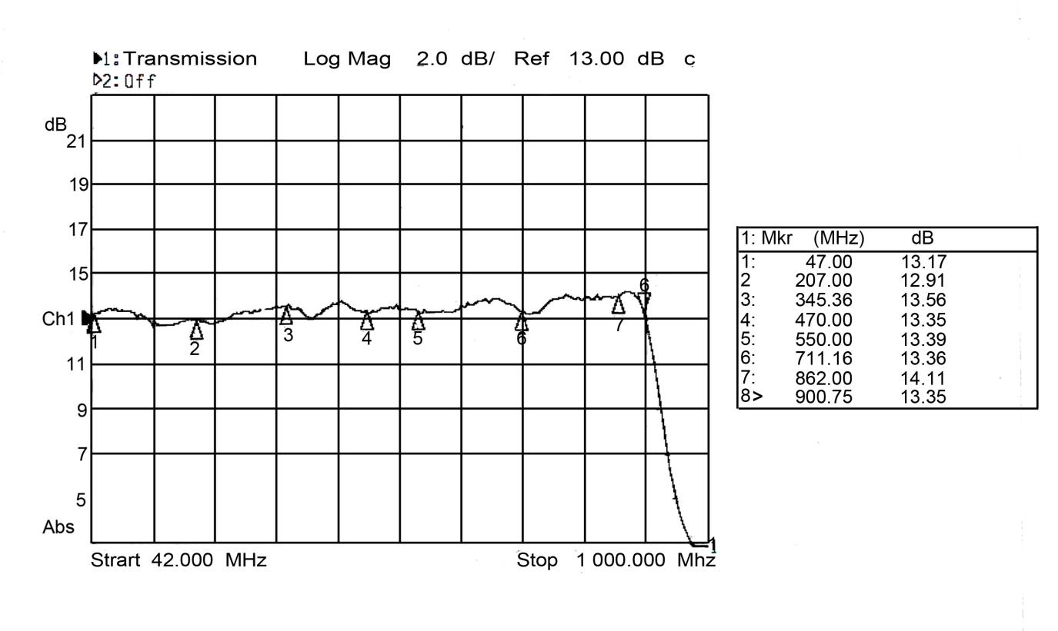**Flatness**

**CNR, MER Degradattion table**

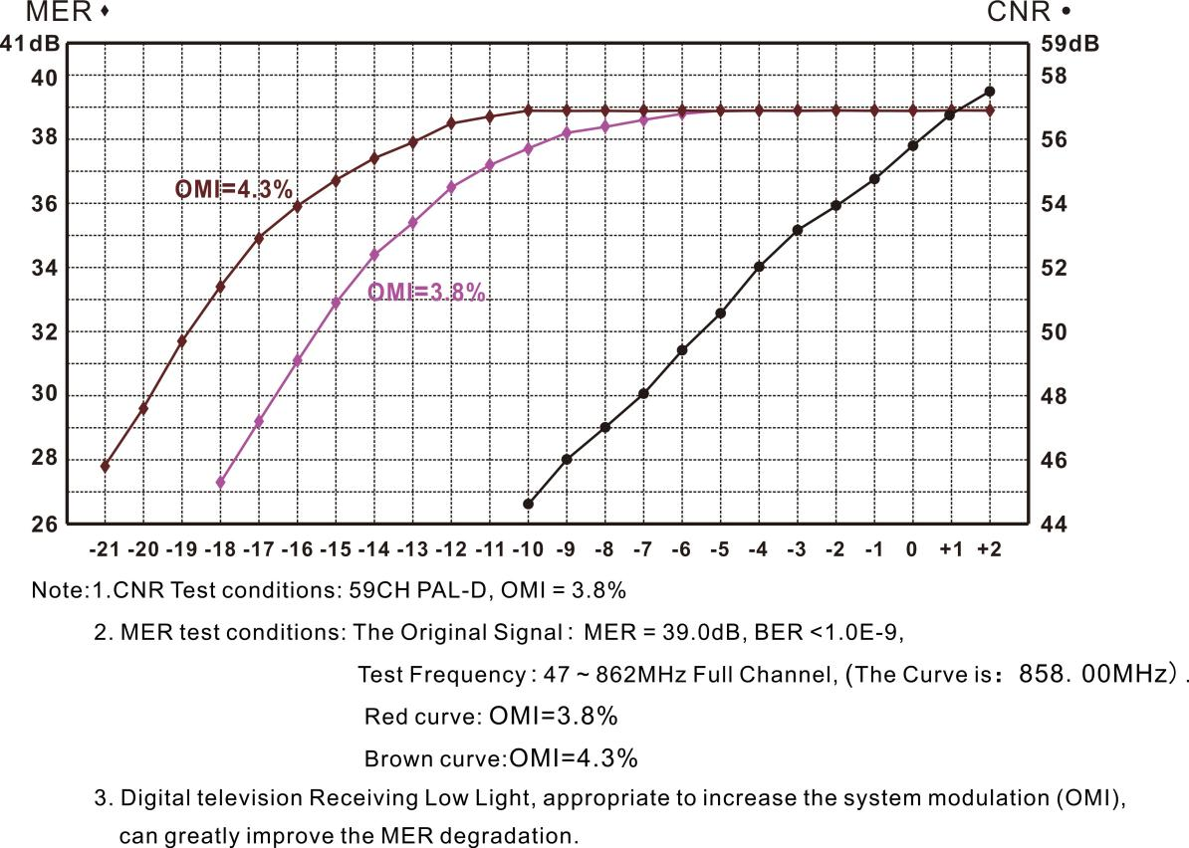

**Analog TV test data ( PAL-D59CH, OMI＝3.8% )**

|  |  |  |  |  |  |  |  |  |  |  |  |  |  |
| --- | --- | --- | --- | --- | --- | --- | --- | --- | --- | --- | --- | --- | --- |
| Pin(dBm) | +2 | -1 | 0 | -1 | -2 | -3 | -4 | -5 | -6 | -7 | -8 | -9 | -10 |
| Vo(dBμV) | 94.5 | 92.7 | 92.8 | 92.5 | 92.4 | 92.7 | 92.4 | 92.3 | 92.4 | 91.3 | 90.2 | 87.7 | 86.9 |
| PAD(dB) | 15 | 15 | 13 | 11 | 9 | 7 | 5 | 3 | 1 | 0 | 0 | 0 | 0 |
| CNR(dB) | 57.0 | 56.8 | 55.6 | 54.8 | 54.1 | 53.4 | 52.3 | 50.9 | 49.8 | 48.5 | 47.5 | 46.5 | 45.2 |
| CTB(dB) | 65.3 | 66.7 | 68.1 | 69.0 | 71.1 | 70.4 | 71.0 | 74.2 | 72.8 | 74.2 | 72.3 | 73.1 | 69.0 |
| CSO(dB) | 67.2 | 67.3 | 70.0 | 65.5 | 67.8 | 64.5 | 64.8 | 67.6 | 65.4 | 70.1 | 65.9 | 67.9 | 65.5 |

**Digital TV test data ( Pin=+2.0dBm ~ -20.0dBm )**

|  |  |  |  |  |  |  |  |  |  |  |  |  |
| --- | --- | --- | --- | --- | --- | --- | --- | --- | --- | --- | --- | --- |
| Pin  (dBm) | Vo  (dBm) | PAD  (dB) | MER | BER | |  | Pin  (dBm) | Vo  (dBm) | PAD  (dB) | MER | BER | |
| POST | PRE | POST | PRE |
| +2.0 | 101.6 | 15 | 38.9 | <1.0E-9 | <1.0E-9 | -10.0 | 94.1 | 2 | 38.9 | <1.0E-9 | <1.0E-9 |
| +1.0 | 99.6 | 15 | 38.9 | <1.0E-9 | <1.0E-9 | -11.0 | 92.0 | 0 | 38.7 | <1.0E-9 | <1.0E-9 |
| +0.0 | 97.7 | 15 | 38.9 | <1.0E-9 | <1.0E-9 | -12 | 90.0 | 0 | 85.5 | <1.0E-9 | <1.0E-9 |
| -1.0 | 98.5 | 15 | 38.9 | <1.0E-9 | <1.0E-9 | -13 | 88.1 | 0 | 37.9 | <1.0E-9 | <1.0E-9 |
| -2.0 | 98.6 | 15 | 38.9 | <1.0E-9 | <1.0E-9 | -14 | 86.4 | 0 | 37.4 | <1.0E-9 | <1.0E-9 |
| -3.0 | 98.7 | 11 | 38.9 | <1.0E-9 | <1.0E-9 | -15 | 84.1 | 0 | 36.7 | <1.0E-9 | <1.0E-9 |
| -4.0 | 98.7 | 9 | 38.9 | <1.0E-9 | <1.0E-9 | -16 | 82.1 | 0 | 35.9 | <1.0E-9 | <1.0E-9 |
| -5.0 | 98.6 | 5 | 38.9 | <1.0E-9 | <1.0E-9 | -17 | 80.4 | 0 | 34.9 | <1.0E-9 | <1.0E-9 |
| -6.0 | 98.4 | 5 | 38.9 | <1.0E-9 | <1.0E-9 | -18 | 78.7 | 0 | 33.4 | <1.0E-9 | <1.0E-9 |
| -7.0 | 98.5 | 5 | 38.9 | <1.0E-9 | <1.0E-9 | -19 | 76.8 | 0 | 31.7 | <1.0E-9 | <1.0E-9 |
| -8.0 | 98.5 | 5 | 38.9 | <1.0E-9 | <1.0E-9 | -20 | 74.8 | 0 | 29.6 | <1.0E-9 | <1.0E-9 |
| -9.0 | 96.1 | 3 | 38.9 | <1.0E-9 | <1.0E-9 |  |  |  |  |  |  |

**Product series**

|  |  |  |  |  |  |
| --- | --- | --- | --- | --- | --- |
| Model | Input  wavelength | CATV operating wavelength | Data pass wavelength | Fiber  connector | Form |
| H9122L | 1310 or 1550nm | 1260~1620nm | - | SC/APC | A - Type |
| H9122L/WF | 1310, 1490 / 1550nm | 1540~1563nm | - | SC/APC |
| H9122L/WD | 1310, 1490 / 1550nm | 1540~1563nm | 1310/1490nm | LC/APC | B - Type |

**Model explanation**

